Auckland Cat Club
DOMESTIC CATS ENTRY FORM
Circle or Print Clearly

Exhibits Name: |  | Colour:
Group: Cat / Kitten | Type: Longhair / Shorthair |  | Sex: Male / Female / Neuter / Spay |  | Approx Age:
Owner’s Name:
Mr/Mrs/Miss/Ms
Address:

Email: |  | Telephone No:

 | RING 1 | RING 2 | RING 3 | RING 4
Entering:

Entry Fee | $
Benching Fee ($20 first entry only) | $
Catalogue ($9) | $
Membership | $
Cage Hire ($5) | $
Rosettes ($70) | $
Donation | $
TOTAL | $

I/We consent to be bound by and submit to the Constitution, Bylaws and Rules of the NZ Cat Fancy Inc. and the Club as may be amended from time to time as well as the “Rules, Instructions and Regulations” in the schedule.

(A copy of the NZCF Show Bylaws may be obtained as detailed in the schedule).

Privacy Act: I/We agree to my/our Name and Prefix being printed in Catalogue: Yes/No
Cross out if any of these not to be printed

I offer my services as (Please tick): Steward ( ) Handler ( ) Scribe ( ) Other ( )

Hire club cage: __________ Size preferred:________________
Bringing own large cage ____(pls specify dimensions N.B. Max frontage no more than 760mm):________

Signed:______________________________Date____/____/____
You can make payment by Internet Banking to ASB Bank Acct# 12 3232 0024558 01. Please include your NAME in the Particulars box & the words Shw Fees in the Reference/Code Box.

OFFICE USE ONLY
Cage No: | Underpaid: | Overpaid | Receipt No:

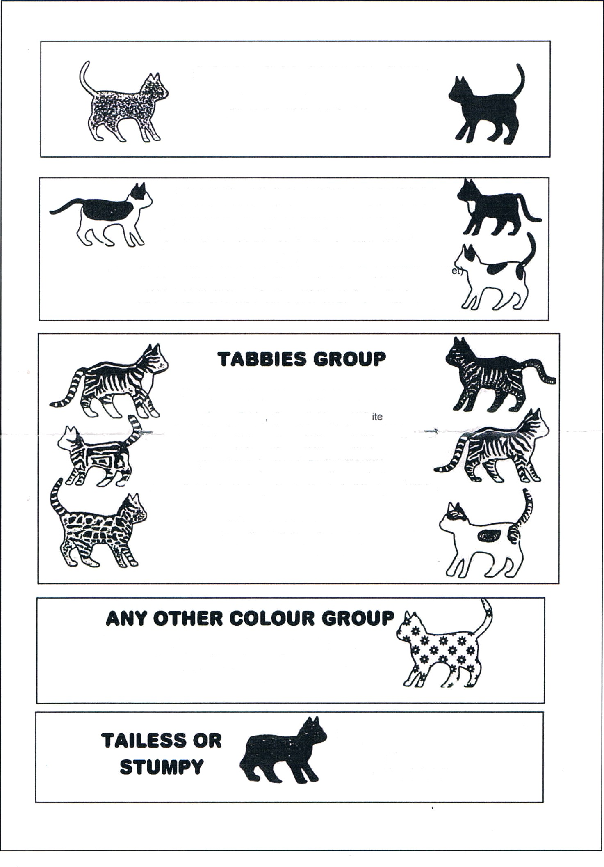

SOLID COLOUR GROUP

All Black, All Blue (grey),
All White, All Red (ginger)

BROKEN COLOUR GROUP
Black & White, Blue (grey) & White, Tortoiseshell, Tortoiseshell & White, Blue-Cream, Blue Cream & White, Smoke, Smoke & White, Black with A Few White Hairs, also…

…any Solid Colour with a White Locket or Tummy Spot (e.g. Red with White Locket), White with Black Patches, White with Blue (grey) Patches, White with Red (ginger) Patches, White with Cream Patches, White with Tortoiseshell Patches, White with Blue-Cream Patches.

.

Any colour allowed
Stumpy – with a bob tail.
If your cat or kitten
will not fit into any of the other colour groups,
then it belongs here.
Blue (grey) Tabby, Blue (grey) Tabby & White,
Silver Tabby, Silver Tabby & White,
Cream Tabby, Cream Tabby & White,
Red (ginger Tabby, Red (ginger) Tabby & White,
Brown Tabby, Brown Tabby & White,
Tawny Tabby, Tawny Tabby & White,
Smoke Tabby, Smoke Tabby & White,
Tortoiseshell Tabby, Tortoiseshell Tabby & White,
Brown Tortoiseshell Tabby, Brown Tortoiseshell Tabby & White

also… …any other colour Tabby,
…any Tabby with a White Locket or Tummy Spot
(e.g. Brown Tabby with White Locket).

- PLEASE STATE COLOUR OF TABBY PATCHES

